Statement of Work

CNC0600 Canadian Work Rest Phase 2

Version: 2.3

*Prepared for*

Canadian National Railway

*by*

PS Technology

248 Centennial Parkway, Suite # 150

Louisville, Colorado 80027

303-527-2000

303-527-2001 (fax)

April 4, 2023

Proposal valid until April 09, 2023

CNC0600 Canadian Work Rest Rules Phase 2

**Preparer and Reviewers from PS Technology, Inc.:**

Radford Walker Steve Muller

Systems Engineer – Legacy Systems Senior Systems Engineer – Legacy Systems

Keith Svancara Chris Phillips

AVP – Product Development Associate Systems Consultant - Marketing

**Requestors, Contributors, or Reviewers from Canadian National Railway Company:**

Cathy Whiteman Quốc Hoàng

Senior Manager Crew Systems and Scheduling Crew Systems and Scheduling

**Proprietary Notice**

This document is the property of **PS Technology, Inc.** and **Canadian National Railway Company (Company)**. The information contained herein is reserved as proprietary to both **PS Technology, Inc.** and **Canadian National Railway Company (Company)** and may not be published, reproduced, copied, disclosed, and/or used outside of **PS Technology, Inc.** or **Canadian National Railway Company (Company)** without the written consent of a duly authorized representative of **PS Technology, Inc.**

**Source Document Statement**

This document outlines the specifications for the **Canadian Work Rest Rules Phase 2**. Its purpose is to specifically detail the changes to the existing system and new processes that are necessary to accommodate the requirements submitted by **Canadian National Railway Company (Company)** to **PS Technology, Inc.**

This document will be used as the sole source document for the administration of this project**.**

**Document Revisions**

| **Version No.** | **Description** | **Function No.** | **Requested By** | **Revision Date** |
| --- | --- | --- | --- | --- |
| 1.0 | Initial Document |  |  | 02/06/23 |
| 1.1 | Estimated runtime | 3.7 | CN | 02/09/23 |
| 1.2 | Schedule | VII | CN | 02/14/23 |
|  | Estimated runtime | IV 3.7 |  |  |
|  | New items | IV 11, 12, 13 |  |  |
|  | Change of status | IV 1 b and c |  |  |
| 1.3 | General wording and clarifications |  | Both | 02/14/23 |
| 1.4 | Specify 24 hours days | IV 1 a | CN | 02/20/23 |
|  | add passenger service reset |  |  |  |
| 2.0 | Concept change. New work rest cycles put employee’s into non-callable status. | III scope  IV rearranged  VII schedule | Both | 02/28/23 |
| 2.1 | Add summary of colors | IV.G.11 | PST | 03/06/23 |
|  | Access to Canadian HOS log from field menu | IV G 12 | CN |  |
|  | Load Test | IV.G.13 |  |  |
|  | “Commuting” record type on HOS log | IV.G.14 |  |  |
|  | Include Prep Time | IV.G.15 |  |  |
| 2.2 | Comment – not monitor next call | IV.A.3 |  | 03/28/23 |
|  | Q / As about OUTPOST | IV.B.4 |  |  |
|  | 5 new requirements for end of reset | IV.B.6 |  |  |
|  | Q / A DH vs assignment | IV.B.3 |  |  |
|  | Q / A override questions | IV.C.5 |  |  |
|  | Q / A yellow status questions | IV.C.5 |  |  |
|  | Q / A 3 incidental questions | IV.C.6 |  |  |
|  | Notes about AFH during call | IV.C.7 |  |  |
|  | Q / A who can mark off | IV.D.2 |  |  |
|  | Q / A E-95 vs other status | IV.D.4 |  |  |
|  | Correction in wording | IV.D.8 |  |  |
|  | Q / A undisturbed rest inclusive? | IV.D.8 |  |  |
|  | Q / A Where message goes | IV.D.9 |  |  |
|  | Q / A restricted rest 8 hrs? | IV.D.9 |  |  |
|  | Q / A during call? | IV.D.10 |  |  |
|  | Q / A written at tie up or call | IV.D.11 |  |  |
|  | 3 new requirements for HOS log | IV.D.12 |  |  |
|  | Q / A when mark natural reset | IV.E |  |  |
|  | Q / A where display expt return | IV.G.1 |  |  |
|  | Q / A formatting for lead time | IV.G.3 |  |  |
|  | Additional information avail status | IV.G.11 |  |  |
|  | Incidentals commuting and contacted | IV.G.14 |  |  |
|  | Ignore prep time 15 minute limits | IV.G.15 |  |  |
|  | New requirement dynamic text on screens MTOY and MTOR | IV.G.16 |  |  |
|  | new requirement outpost flag on pool | IV.G.17 |  |  |
|  | Additional info on tie up modification | IV.G.18 |  |  |
|  | Process for override red employee | IV.G.19 & appendix C |  |  |
|  | New requirement outpost on crew profile | IV.G.20 |  |  |
| 2.3 | In RED |  |  |  |

**Statement of Work for CNC0600 Canadian Work Rest Rules Phase 2**

PS Technology, Inc. (“PST”) and Canadian National Railway Company (“Company”) enter into this Statement of Work No. xxI (“SOW”) on ___________ (“SOW Effective Date”). This SOW is governed by the Master License and Services Agreement dated xxx (xxxxx) the “Agreement”) between PST and Company. Unless otherwise defined in this SOW, terms set forth in initial uppercase letters have the meaning established in the Agreement. PST agrees to complete the following project in accordance with the Agreement and the following terms:

**I. Project Overview**

The purpose of the project is to bring the PST Crew and Time Management System (CATS) into compliance with the Notice of Approval to Canadian Duty-Rest Rules issued by The Railway Association of Canada dated November 25,2020 (TC O 0-255) with subject: *Duty and Rest Period Rules for Operating Employees*. Changes described in the notice are to be phased in as designated in the document.

The purpose of this document is to define the scope, responsibilities, and approximate schedule for the working and completion of the project *Canadian Work Rest Rules Phase 2*.

**II. Term of SOW**

This SOW commences on the SOW Effective Date and terminates 05/23/2023, or such other date required to complete the Services and Deliverables.

**III. Scope of Work**

Phase 2 project covers the changes in the cumulative duty periods within designate periods of time, which when fulfilled forces the employee into a reset break as described in the TC document.

This SOW covers PST changes to programs, maps, copy books, JCL, TIPS, which will result in changes to CATS behavior which can include but not limited to additional entries on the task list, employee history report. It does not cover any CN practices that might have to be adjusted due to the additional rest time given the employees.

**IV. Description of Work**

This section includes the functions for which PST will modify the programs and process of CATS to accomplish the goals of the project.

1. **Determination of Reset Break for Freight**

A reset break as defined by TC document is a period tie up at home of at least 32 hours off duty that includes two 8 hour night time periods between the hours of 22:00 and 08:00 where they are not disturbed by railroad business. These two nighttime periods are called “undisturbed rest” in the rest of this document.

The duration of the rest period will not always be 32 hours, but is dependent on the time of day the reset break begins. It can be up to 53:59 hours in duration. See chart in Appendix A.

1. Employee will be put into a reset break when they have worked 7 consecutive days without a reset break.

These are 24 hour periods, so the 7 day period can begin and end at any time of a calendar day. Being within 7 days means it must be shorter than 7 days or a max of (168 hours minus one minute, or 10,079 minutes). CATS will not count seconds, so in effect all seconds will round down.

1. Employee will not be allowed to be called to duty when they have worked 60 or more hours within 7 day period, or they have worked 192 or more hours within a 28 day period. These are 24 hour days. They will be displayed in red on the call and inquiry screens.
2. Employee’s work history will be monitored to determine if their work history has allowed them to have a rest period that conforms to the parameters of the reset break. In this case it will be considered a natural reset break that counts the same as a forced reset break.

PST Comment – We may not monitor work history to consider natural reset break, our next call will determine whether natural reset break has happened. CN – OK.

1. **System Forced Reset Break Because of 7 Days Work.**
2. CATS will keep a count up to the 7 day max for time worked without a reset break.
3. Every time an employee **ties-up**, the system will check to determine how close the employee is to a required reset break.
   1. When the employee is within 2 hours of a required reset they will immediately be put into a rest break. (superseded by B.6 )
   2. When the employee is going into a mandatory rest period and the reset break is within that rest period, the mandatory reset break will begin immediately and run concurrently.
4. Every time an employee is to be **called**, CATS will check to see if there is enough time to complete the turn and end up home before a reset break needs to begin. If not, the employee will be marked in red and should be rejected for this assignment.

The length of the tour will be estimated:

For yard and local assigned jobs examining the schedule for the assignment being called.

For road jobs it will first be considered if the employee is at home or at an away terminal. It will then use the appropriate source for that situation. Either the Run Miles Table (PSTS525) or the Estimated Run Time from the Alternate Crew Source Control (PSTS122). Look at the estimated time for both to determine which is from the home terminal.

For jobs being called from home, the trip to and from the away terminal will be used as well as the minimum 10 hour AFH rest. Doubling the amount from above is sufficient rather than calculating both directions separately.

When an employee is presented on the call screen and calculated to be in the end of the period, CATS will still present but with a limitation message. Message something like, “Cannot be called. Employee does not have enough hours to complete turn.” CATS will not allow the user to call the employee to duty.

Note - Need some sort of flag the crew dispatcher and look at how the system calculated the tour run time and be able to still call the employee if they can work half and be deadheaded home. Explained and basically superseded by G.19.

1. For the purpose of these calculations, outpost assignments (remoted worksite) are considered to be treated as away from home. Employee deadheaded to an assignment at the remote worksite will be put into 10 hours rest at the end of the deadhead to be rested for the next assignment.

Question- How to identify remote (outpost) assignments?

Answer – Extra Board when DH to last temp assignment and “held away”

Pool Board – Add new flag to the pool board maintenance screen.

Crew Profile – Add new flag to the crew profile maintenance screen

Additional requirements

a. Add OUTPOST flag to pool board maintenance screen. (See G.17

b. Add OUTPOST flag to crew profile maintenance screen. (See G.20)

1. When an employee **ties up** at home with less than 8 hours of time before the 7 day period ends, start the employee’s rest break immediately. This is regardless of hours worked. Subsumed by B6.
2. Additional Requirements for Forced Rest Break.

* Upon tie up at home on the fifth day without a reset break during the last five day, with less than 6hr left on 60/7 clock.
* Upon tie up at home on the sixth day without a reset break during the last six days, with less than 6hr left on 60/7 clock.
* Upon tie up at home on the 7th day without a reset break during the last 7 days, with less than 6hr left on 60/7 clock.
* Assuming the first day of 7 started at 0001. Upon tie up at home on the 7th day with an off-duty of ~~0400~~ 0601or later, without a reset break during the last 7 days, with plenty of hours left on 60/7 clock (~~0400~~ 0601 + 10hr MTOD + 2hr call = 1801 ) order, but must begin reset break at 2359 of day 7th at the latest, so unable to provide a minimum of 6hr.)
* Been available on the 7th day but without a reset break during the last 7 days, plenty of hours on 60/7 clock. if unable to provide a minimum of 6hr (ie, not called by 1559 for an order of ~~1559~~ 1759 ).

Questions: How to trigger this forced reset since there would be no tie up? Back ground transaction? Need to notify both Crew Dispatcher (ie. Info task on task list) and employee (ie how????)?

Answer PST – New transaction to be run in background once every 2 hours.

Note: The program is keeping a running estimate of the employees next required reset break. This can probably be used in some way to accomplish this.

1. **Employee not callable Because of Hours Worked in Days Interval**
2. CATS will keep counts of Hours of work for both the 7 day and 28 day intervals. Look back for this period of time.
3. Every time an employee is to be called at home, CATS will check to see if the duration of the tour would put the employee over one of the interval thresholds. If not, the employee will be marked in red and should be rejected for this assignment. Program should be performing this today for the 64/7 logic and just needs to be changed for the 60/7 and extended for the 192/28. Employee will be in red status but CMC can override.

Make certain that this calculation is performed after the 7 day reset break check above #B.3.

1. An employee AFH can work home and go over the 60/7 or 192/28 upon tie-up at home as long as the estimate off duty would occur within the 7th reset break days.

They must arrive at the AFH location with less than 60 hours (or less than 192).

1. Dead Head hours count toward the work hours in the day interval sums.
2. When the employee who has not had a reset break in the previous period is being called for an AFH tour he must be home within the 7 days, he must not exceed either of the 60 or 192 work hours upon tie up AFH. When the employee is getting close to these thresholds they will appear in yellow on the call screen. The yellow is to indicate to the crew caller that they must be aware of these limitations before the employee is called to duty.

Do not allow call function when unless overridden with new flag that is set by the crew dispatcher (only when told). When they update the flag jump into work history for a comment of who or why decision was made.

1. Incidental hours for things like training and incidentals count toward the work hours.

Question - How does system know about this and does this trigger a mandatory rest?  
Answer – See G-14

Question – Do incidental hours trigger a mandatory rest?  
Answer – Yes. The act of entering the incidental will not trigger rest but the hours might.

Question – Can incidental hours be entered any time?  
Answer – Yes. Any incidental effective withing the 7 day look back should be included, anything older will not be counted toward current 60/7, but maybe used within the 192/28.

Question – What happens when an incidental is deleted?  
Answer – Recalculation will be triggered at the next board inquiry or call.

1. Remove the work hours from counts if still within the original period.
2. Leave any “in process” rest or reset break to stand as is.
3. Let the next system action (call/tie up/board inquiry) recalculate the callable status (red, yellow).
4. If less than 6 hours remaining before 60 or 192 - red, if over hours - red, if cannot satisfy estimated run time – yellow. When red do not allow call, nor call override, unless it is a dead head home.

Note – AFH during call, if the tieup of new assignment is away, estimated run time should not exceed the 60/192 hours as well as the 7 day reset period. If the tie up is at home estimated run time should not exceed 7 day reset limit.

1. **Actions for a Reset Break**
2. At the beginning of the reset break the employee will be put into status of E reason 95, or E-95 for short. This is currently done for US FRA rest breaks, so the pattern can be copied.
3. While in status E-95 the employee will not be allowed to change their status.

Question – Is this only the employee or also the crew caller?  
Answer – A crew caller can put into any other off status.

1. While in status E-95 the system will not allow status change to any available status before the official return date/time. See 4a and 4b below.
2. At the beginning of the reset break CATS will calculate the duration and create an automatically executing future book-on event for 06:00 at the end of the second undisturbed rest in the reset period. Unless this would violate the 60/7 192/28 type rest periods.
   1. Status will change to Available unless another status with a “due back” ( such as vacation) has started in the mean time in which case the status will remain in in that other status.
   2. If another status with a “due back”/book on has been in effect and ended with in the reset break period, then the book-on for that status will not go back to available but rather return immediately to E-95.
   3. After the reset break an employee may be carrying enough work hours to be close to the 60/7 so they cannot work a full shift. In this case put the employee in yellow as an indication to the crew caller about this situation.

Question – What would be the dueback scenario?  
Answer - If emp has another schedule book off status, execute that but undistrbed rest prds will still apply. Create another bookoff E-95 if vacation end date is less than the reset prd. Make sure that E95 bookon still exists.

Question - E-69 or E95?  
Answer - Which ever is the longest, but note if employee is in E-69 the employee can book on early, so need to remember that they are also under E-95.

Question - When there is another off-board status in effect simultaneously with the E-95 which is the employee presented in?  
Answer - Always the most restrictive.

Further comment – system today handles coming out of another off status into E-95.

1. At the beginning of the reset break CATS will calculate the first undisturbed rest period and populate the start and end date times into fields for the call and phone screens to use to prevent the crew caller from inadvertently calling an employee during this time. This is if somehow employee is presented on a call screen. They cannot be called for service. This is the same requirement as G.9 and subsumed by it.
2. At the beginning of the reset break CATS will calculate the beginning of the second undisturbed rest period and add an automatically executing future event to the task list to repopulate the undisturbed start and end date time fields.
3. The notification flag on the IVR will be set to “do not call” during these periods. Along with the MDOT the to and from night periods will be considered as the IVR flag as the employee is under mandatory rest. And cannot be called. Three things. Flag, MTOD, and TO/FROM any of these will prevent CATS from requesting IVR call.
4. The reset break has two undisturbed periods in it, from 22:00 to 08:00 the first day and 22:00 to 06:00 the second day. CATS will not allow the IVR to make a call to an employee on reset-break during these time periods. CATS will not allow the crew caller to initiate a call through the system during this time. Appropriate message will be displayed something like “Employee in undisturbed reset break”.

Messages to employees can be created during this time, but CATS cannot allow these notifications to be sent to the IVR during these undisturbed rest period. Messages will be sent at the end of the undisturbed rest periods.

Question - Is the undisturbed rest 2200-0800 period inclusive of one, the other, or both of those times?  
Answer - First night is 22-08 inclusive or any off-duty time between 2200-2359 to the next day. For the second night undisturbed must be 2200-0559. In other words system can call at 0600 for duty at 0800.

1. New functionality on call screens (08, 08S,08Z) to check for CALL actions (CALL, VCALL, etc) and be certain the action time of the call is not in an undisturbed rest period of a reset break or less than the MTOD, or US rest (per rest required on the crew profile), whichever is most restrictive.

If the action time is prior to the end of either of these disallow the process and provide the crew dispatcher a message “Employee is on undisturbed rest until xx:xx”. This message goes in the line that normally holds the phone number, so the number is unavailable to the dispatcher to call from.

Narrative Description - On call screens, existing system logic will determine if employee is avail for call based on the order date/time. This logic needs to be retained. However, additionally, need logic to monitor action time when call is submitted on the call screens since employee must have an undisturbed of 8hrs. (ie. employee tied up at home at 2200. With 10hr MTOD at home, his mandatory rest would expire at 0800. With a 2hr call, he's being called for 1000 order. This is acceptable so far. However, since the WRR requires employee to have at least 8hr undisturbed, and the current logic of VCall would be sent to the IVR for execution immediately at submission, the system should not accept any call submission on the call screens for this employee prior to 0800 clock time. This will avoid the IVR calling the employee to work before observing a minimum of 8hr undisturbed.)

Question - Where on screen to put the “Employee is on undisturbed rest until xx:xx”?  
Answer - Should be individually under the name of the affected crew member(s), ie telephone field.

Question - Employee will be on Red until the MTOD is completed. We are not restricting to 8 hrs in this case in phase 1.  
Answer - Do not attempt to determine which is the restricted rest Just use the whole MTOD.

1. CATS will write a reset break record on the HOS log following the record of tour of duty on which the Imposed Reset Break occurs.

Question – Is this during Call.  
Answer - . Definitely write during the tie up that forces them on. No, do not re-write during the call. The call itself will be on the employee history and HOS log. Only a natural reset break will be written during the call after the fact.

1. CATS will put an employee work history record on file for an employee going into a reset break. The record will include how many hours the break will be and start and end of the undisturbed rest periods there in. Record will include the date/time of the end of the reset break. Employee cannot be booked on before this end date time period is past.

Question – Should this record be written during tieup or during the next call? In case of natural reset, it was advised to write during next call) If we write the rec during the next call, then the hist rec will have the exact time the employee was on reset brk.  
Answer – Follow same logic as E-69. All triggered on tie up.  
 Later answer Forced at tie up time, Natural at next call.

1. Additional Requirements on work history entry

* Use “RESET BRK” verbiage.
* Include weather the reset event is forced or natural.
* Use shift right screen (F10) and second line if necessary to get all information included

1. **Determining a Natural Reset Break**

Question – How to mark when an employee has completed a natural reset break.  
Answer – Write on HOS log and Employee History file upon next call to work.

1. CATS will have a running count of off duty time (rest) to monitor the employee’s time to determine if a natural reset break has occurred.
2. At tie up time where an employee is put into any type of rest period the count down (actually a count up) for having natural reset break will begin.
3. Every call to duty for the employee resets the computation of a natural reset break back to the beginning.

This is unless this is the call that will bring them back to duty at the end of the reset break.

1. Other official calls to the employee will reset the natural reset break computation to the beginning if that call occurs during an undisturbed rest period. This will be an incidental entry in the Canadian hours of service log. Cats will have to be modified to allow the callers to put this entry into the log.
2. When the rest hours count gets to be equal or greater than 32, CATS will check to determine if that time contains two night time undisturbed rest periods. If so it will write a reset break record on the HOS and employee history that the employee has completed a natural reset break, and begin the 7 day work period from that point.
3. When an employee has been last tied up at the home terminal for a period of 53 or greater hours the CATS system will assume a natural reset break has occurred and begin the 7 day work period from that point, and the employee has not been contacted.
4. When an employee marks up and is not called to duty, the start of the 7 day working period will be postponed (pushed out) until such time the employee is called to work. On duty time.
5. When an employee is called to duty and has completed a natural reset break in the intervening time, CATS will make an entry onto the employee history that includes when it started, the from and to of the 2 undisturbed rest periods. In a call and cancel at home situation undo the history record. (codes used for this are RL - release or CC – call and cancel).
6. **Passenger Train Reset Break**
7. ~~CN crews the Rocky Mountaineer passenger service and those crews will have to have the TC reset break applied to them. Job type is used to identify a passenger service 28 and 29. Or maybe a flag on the crew profile~~. Will be later work.
8. **Other**
9. On the field inquiry screen, display the employee’s return date/time as that of the E-95 automatic book-on task.

Question- Where on the field inquiry screen to display the employee’s expected Return from reset break?  
Answer – On field menus there are RETN fields. This is the expected return time.

1. A control flag on the sub district screen “CAN WRR” will allow the reset break to be activated. If the switch is off CATS will not perform any of this reset break or duty time-in-duration calculations. Values will be “O” old hours of service “N” new, blank is old.
2. When the WRR control flag is activated, CATS will enable the “no short lead” logic same as if it were checked on the sub-district maintenance screen 3 (psts145). Two hour calls will always be required. Can we change both these flags (employee and caller) to “N” to solve this. Apparently not, add code to prevent short lead calls.

The no short lead only applies to Canadian profiles.

~~When in no short lead mode the phone number is blocked off on the telephone screen (05P).~~

Do not allow short lead. Block employee from updating their own short lead time.

Question – Should we black out the “FOR THE NEXT CALL I REQUEST A LEAD TIME OF (HHMM))” row on screen S05P when WWR flag is set?  
Answer – When the WWR flag is set:

1. Don’t let user add a lead time value less than that on the sub-district screen.
2. Where ever we use this field, if it is less than the lead time on the sub-dist ignore it.
3. The automatically occurring event placed on the task list will be of a new type that the crew dispatchers can filter off the task list screen and not have them cluttering up tasks that need their attention. Make certain the new type is filterable.
4. A reset break can begin and occur concurrently with other rests the employee may be on or taking.
5. On the *Employee Time On Duty Screen* (PSTS05Y) add a 28 day total and change the current TOTAL TIME field label to 7 day total. Add a flag to allow user to select whether the screen is Table

   Description automatically generateddisplaying a 7 day or 28 day look back. As mock up above.

Narrative - When 'NEW' WRR flag on Sub-Dist, is set, screen should display two running totals, 60/7 and 192/28, clearly labelled as such. However, only display records (both trips and manually created) relating to the 7 day look back. A 'Display 28 day look back' flag should be made avail. when this is yes, display records relating to the 28 day look back.

1. The Canadian HOS Log screen (PSTS50Y) will be modified to allow for a crew dispatcher to manually insert a contact record type. Can use similar logic in the US HOS log (PSTS09D).
2. When an employee’s on duty time exceeds the prescribed 12 hours by more than 4 hours for deadhead at end of tour, their rest period is extended by the amount of time over 12 hours they work or rest terminates at 08:00 which ever is shortest. See TC 7.7 (clarify if this is 06:00 o-clock for 8 hour rest or 08:00 o-clock for 10 hour rest) Clarification when 08:00 occurs before the end of the 8 or 10)
3. When an employee’s on duty time exceeds the 12 hour max for purpose of an emergency their minimum rest period is to be extended by the amount of time their duty exceeds 12 hours or 08:00 which ever is shortest. See TC 7.8

Numbers 8 and 9 above should be similar to what happens in US when FRA hours are exceeded, so can be used as a model of how to do this. Needed but future, and how to tell if emergency? Doesn’t happen that often.

1. Currently there is a reject hours of service, RJHS generates a payment. That should be blocked in the future. Do not accept the function on the call screen. Does not apply to the new work rest rules. When new rules switch is on, this function should be turned off.
2. On a board inquiry, dynamically calculate the employees’ status in regard to their work rest status and display employees in appropriate color normal, yellow, red.

Example a crew dispatcher looking at a pool or spare-board, or a Field inquiry from anyone showing the same color indicators.

Summary of Colors

|  |  |  |  |  |
| --- | --- | --- | --- | --- |
| Item | Home | Situation | color | override |
| 1 | H | Less than 6 hours before due a reset break | red | Yes |
| 2 | H | Estimated one way trip is greater than or equal to time remining before due a reset break (call screen only) | red | Yes |
| 3 | H | Estimated round trip (2x work +10 hours) is greater than or equal to the remaining time before due a reset break (call screen only) | red | Yes |
| 4 | A | Estimated one way trip home is greater than remaining time before due reset break (call screen only) | red | Yes |
| 5 | H | Employee has accumulated work hours equal to or greater than 60/192 thresholds | red | Yes |
| 6 | H | Employee has less than 8 hours of work available before hitting the 60/192 threshold (superseded by #7) | red | Yes |
| 7 | H | Employee has less than 12 hours of work before a 60/192 threshold or end of reset period (Field Inquiry) | yellow |  |
| 8 | H | Estimated work hours for one way trip duration is greater than or equal the remaining hours before hitting 60/192 work threshold.(Field Inquiry) | yellow |  |
| 9 | A | Employee needs to be deadheaded home. (field inquiry) | yellow |  |
| ~~10~~ | ~~A~~ | ~~Spare board if can’t get home by end of 7 days reset period~~ | yellow |  |

Concerning dynamically calculating the employees available status. Additional Information.

Look back triggered on call and board inquiry.

There are different types of board inquiry. To cut down for performance the look back should only be triggered on a POSITION inquiry. Or if board is a Bid Pack pool or Scheduled Spareboards, in which case look back when an “Ordered Inquiry” is requested.

Change – Make the red “override” function available all the time.

1. Make the current Canadian HOS Log (05Y) available on the Field Inquiry menu (02).
2. Perform a load test on the pool and spareboard inquiries to be certain the look back for employee work rest status does not take too long. Look for optimizations.
3. Add additional “incidental” Canadian HOS record types. They are to be called “Commuting” and “Contacted”.

Contacted type is for CMC to record when they have made a contact to an employee. Contact records ~~must~~ may have a duration of zero and if so not counted toward HOS.

Commuting type is for CMC and field employees to record when their commuting time “to” where they report for duty at the home terminal and “to and “from” a train. Commute type records must have a duration greater than zero. Time is counted toward HOS.

On the mandatory rest extension screen (PSTS05Z), while retaining existing functionality, when a Crew Dispatcher or Field Employee extends time on duty at the AFH, also have the system to generate a ‘commuting’ HOS record to capture the time in the affected employee’s HOS Log.

Note 1 – The rest extension gets applied to the entire crew. This is current functionality.

Note 2 – If the system attempts to enter a commuting type for a start time that is equal to some event already in the Employee Time On Duty Log (HOS), it will be rejected by the system as a duplicate. The program will not abend but will continue to other crew members and put an error message to the users that “one or more crew members were not updated”.

Note 3 – Commuting record type automatically added can overlap existing incidental records.

Note 4 – Commuting records “STATUS AT CALL” will show “red”.

Option #048 on the Field Menu. It’s only presented to affected employees when they are on MTOD at the AFH.

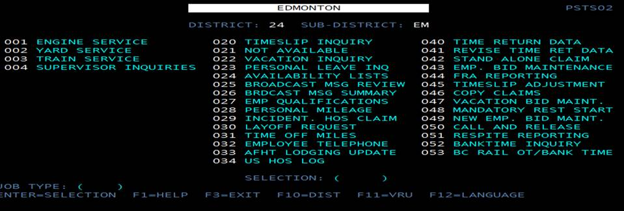

When mandatory rest start has been entered on screen below, also add a commuting record to HOS log.

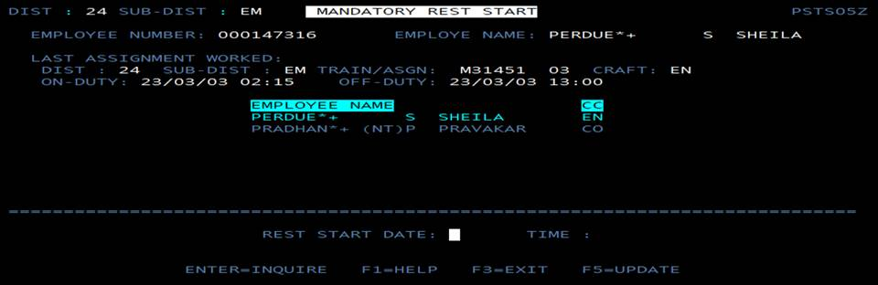

1. CN existing HOS log record calculation does not include prep time if it’s less than 15 minutes, and Final Inspection time that is over 15 minutes. Under the new WRR, all on-duty time is included, including prep time and Final Inspection time. CATS will need to change to accommodate this new WRR requirement. Basically, time on each tour of duty will consist of all time from on-duty to off-duty.
2. Additional Requirement

When reusing fields for the new WWR. When the dist/sub dist flag is set, the display text for the fields should change on the screen(s) from MTOY and MTOR to FROM and TO.

1. Additional Requirements

Make an outpost flag on the Pool Maintenance Screen.

A pool will be set up entirely for the outpost assignment. The outpost could possible be operating from the outpost location (their home terminal) in straight-away and tie-up at an AFH location, then be ordered back.

Example of a true Outpost pool in Cats today: Edmonton (24EM) but this assignment 550 is set up on pool C3, with Mirror (81918) is its home terminal. The assignment itself then may be called in Mirror turnaround or Mirror to Reddeer, then re-order Reddeer back to Mirror. There is an existing H/A field on this screen (Home/Away on the second row). If possible, convert this field to H/A/O (Home, Away, Outpost). The flag will be ‘H’, ‘A’, ‘O’. Blank defaults to ‘H’.

1. Additional Information

Question - Can a tie-up time be modified after the fact, such as after quick tie and they come back to finish the tie-up?

Answer - Should only trigger on actual tie up. Existing system logic writes an HOS at qtie, and update the record at actual tie-up. No new functionality here. Note: CATS is revising today, but employees are not generally allowed to quick tie. Only Yard Masters do this for the shift.

1. Process for Crew caller to override employee in red status.

See Exhibit C.

• Include an edit in this process to only the override on the call screen on each crew member one at a time. Override function ‘HOSO’ should not be allowed on more than one crew member at a time.

• This override functionality, once entered, should not be required to be entered again on the same call (for the same train symbol/origin/destination/order date/time) until the completion of the call or employee being released from it.

• This override functionality should be triggered by all call and miscall functions (CALL, SCAL, VCLL, MC**).

1. Additional Requirement –

Add an outpost flag on the Crew Profile Screen.

21. Disturbed contact allows an additional 8 hours rest.

**V. Assumptions**

1. The 24 imposed rest is gone with this project.
2. In earlier discussions on this topic it was stated that these values for numbers of hours and thresholds are going to change so seldom CN did not think it would be constructive to made them configurable via a profile. As such they will be hard coded into the program.

APPENDIX A

Reset Break Length vs Hour of the Day the Break Begins

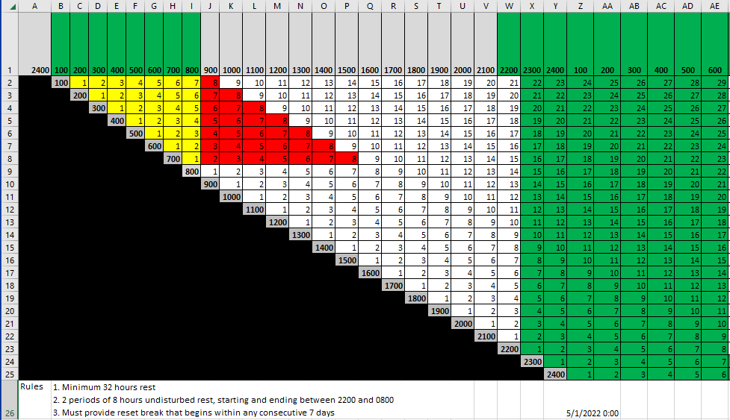

APPENDIX B

Reset Break Scenario Example

Pd Start = The start of the current work period – 1/5/23 08:00

Pd End = The end of the current work period – 1/12/23 07:59

Restart = The date/time when the period will restart – 1/09/23 12:00

Example 1 –Watching for and adjusting a Natural Reset

Call 1 = 1/10/23 08:00 -

Call < Pd End (-8) – No action

Call > Restart - Update Pd Start = 1/10/23 8:00 Pd End = 1/17/23 7:59

Tie-up 1 = 1/10/23 16:00

Tie-up < Pd End – No action Update Restart = 1/13/23 6:00

Call 2 = 1/11/23 09:00

Call < Pd End (-8) – No action

Call < Restart – No action

Tie-up 2 = 1/11/23 16:00

Tie-up < Pd End – No action Update Restart = 1/14/23 06:00

Call 3 = 1/12/23 08:00

Call < Pd End (-8) – No action

Call < Restart – No action

Tie-up 3 = 1/12/23 15:00 Update Restart = 1/15/23 06:00

Tie-up < Pd End – No action

Call 4 = 1/15/23 10:00

Call > Restart - Update Pd Start = 1/15/23 10:00 Pd End = 1/22/23 09:59

Call < Pd End (-8) – No action

Tie-up 4 = 1/15/23 18:00 Update Restart = 1/18/23 06:00

Tie-up < Pd End – No action

Call 5 = 1/16/23 15:00

Call < Restart – No action

Tie-up 5 = 1/16/23 23:00 Update Restart – 1/19/23 06:00

Tie-up < Pd End – No action

Full set of scenarios in document called simple resetBreak.xlsx. Second tab titled “Scenarios”

APPENDIX C

Dialog and Mock Ups for Overriding an Employee in Red “un-callable” status

An employee is marked red during call. He will be displayed as below.

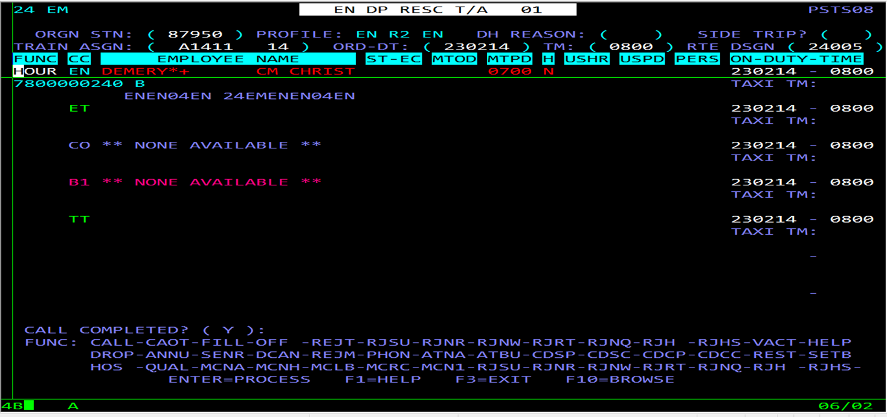

When call is attempted, an error msg will be displayed. If it is a HOS exception that has the facility to override, below will be the message.

When a user enters 'HOSO' on the function and presses enter, the Comments screen will be displayed where he will enter why he is overring and other details.

Comments are entered and press PF5 to update.  Then PF3, to go back to call screen.

Below message will be displayed.

The history looks something like this after call and tieup. Having 'HOS OVRD' saying we have overridden HOS rule and followed by 'Comments' and then 'call'.

